CSTH Celebrates
May 2025 edition

Congratulations to CSTH students, faculty, and staff for their recent achievements!

Department of Biology

Dr. Rachel Lasley-Rasher contributed to a scientific article published in January. The lead author, Evelyn Layland, was a graduate student at the University of Maine and Dr. Lasley-Rasher served on her committee. Dr. Lasley-Rasher worked with USM undergraduate, Molly Spencer, to complete experiments in summer 2020 and 2021 that contributed to this paper. Molly is also listed as a co-author! This project combined rare behavioral observations of larval lobsters with field surveys and prey-choice experiments. This paper was a collaboration between USM, UMaine Darling Marine Center, and Bigelow Laboratory for Ocean Sciences. Watch videos of free swimming stage I lobster larvae and stage IV lobster larvae.
Citation: Layland, E.M., Patrick, E., Spencer, M., Lasley-Rasher, R., Fields, D.M. and Wahle, R.A., 2025. Larval ontogeny enhances resilience to a patchy planktonic food supply in the American lobster (Homarus americanus). Fisheries Research, 281, p.107179.

Dr. Rachel Lasley-Rasher co-led the Marine Ecology Workshop held at Bigelow Labs focused on interdisciplinary research combining marine biology, engineering, and small-scale fluid-dynamics. Six USM undergraduates participated along with 5 students from Florida Atlantic University. This workshop was supported by an NSF-RUI grant and held at no cost for students. Students provided their reflections on the workshop.

Department of Computer Science

Aidan Bell and James Gore have an accepted paper titled “Augmenting Cross-Modal Art Retrieval: The Role of MLLM-Synthesized Captions” at ACM SIGIR 2025. SIGIR is an A* conference, according to the ICORE Conference Portal. While it marks Aidan’s first publication, James previously published at the ACM ICTIR and ECIR Conferences.
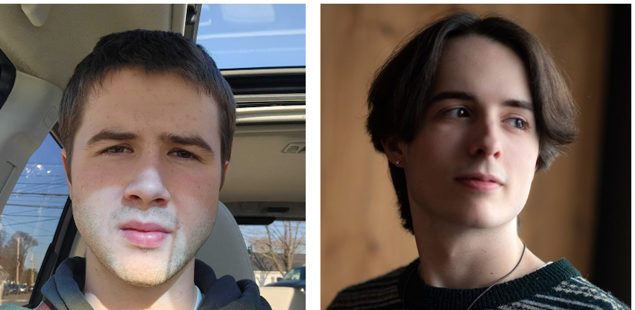
This paper is the outcome of Aidan and James’s project in the Information Retrieval course at the Department of Computer Science at the University of Southern Maine. Aidan and James explored the use of Multi-Modal Large Language Models (MLLMs) for the challenging task of art retrieval, where the goal is to match textual descriptions with relevant artworks. By fine-tuning two retrieval models, Long-CLIP and BLIP, on both human-annotated and MLLM-generated captions, the study finds that MLLM-generated captions can yield comparable retrieval performance to human annotations.

Two research papers led by Computer Science students and faculty were accepted for presentation at the 23rd IEEE/ACIS International Conference on Software Engineering, Management and Applications (SERA 2025), a prominent venue for interdisciplinary research in software engineering and applied computing.

1. XcepKNN: Leveraging Hybrid Deep Learning for Enhanced MRI-Based Brain Tumor Classification
Authors: Ethan Gilles, Yuqi Song, Xin Zhang, Fei Zuo
This paper highlights the exceptional work of Ethan Gilles, an undergraduate student and first author, who collaborated closely with faculty to address a critical challenge in medical diagnostics: accurate and early brain tumor detection. The research introduces XcepKNN, a novel deep learning architecture that integrates the Xception convolutional neural network with a K-Nearest Neighbor classifier to classify brain tumor types using MRI scans.
Tested on a dataset of 7,023 MRI images, the model achieved superior results compared to traditional methods, excelling in accuracy, precision, recall, and F1 score. The open-source implementation of XcepKNN provides a promising tool to support clinicians and researchers in improving diagnostic workflows for brain tumor detection.

2. Analyzing and Predicting Employee Turnover in the Restaurant Industry
Authors: Xin Zhang, Sarah Kayembe, Forest Ma, Yuqi Song, Fei Zuo
The second paper, which features Sarah Kayembe, a graduate student in the Computer Science program, as the second author, results from a collaborative project with the Tourism and Hospitality program at USM. The study tackles the persistent issue of high employee turnover in the restaurant industry by applying machine learning (ML) and deep learning (DL) models to real-world survey data.
Using a dataset of 778 employee responses, the team explored predictors of turnover, such as job satisfaction, compensation, and perceptions of management. Through models like Decision Trees, Random Forests, and Deep Neural Networks, the paper identifies actionable insights and predictive indicators to aid restaurants in developing effective employee retention strategies.
These recognitions at SERA 2025 underscore the Computer Science Department’s commitment to student-led innovation, interdisciplinary research, and real-world impact. Congratulations to all the authors on this significant achievement!

A University of Southern Maine (USM) team presented their innovative research at the Consortium for Computing Sciences in Colleges Northeastern Conference (CCSCNE). The presentation, titled “Large Language Models and Introductory Lab Exercises: Susceptibility, Resistance, and Potential”, opened the conference and sparked significant discussion among attendees.
The project was led by Devin Chamberlain (Cybersecurity ’25), Abby Pitcairn (Computer Science ’25), Nicholas Snow (Information Technology ’25), Ben Sweeney (Computer Science ’26), and Professor David Levine from USM’s Department of Computer Science. Their research during the Spring 2024 semester explored how undergraduate students interact with AI tools — specifically, large language models — when completing programming assignments in introductory computer science courses.
Central to the study was an innovative approach: students completed lab exercises while role-playing one of three carefully designed personas, each representing a different attitude toward using AI tools in academic work. These personas ranged from those eager to use AI for shortcuts to those focused on learning and skill development. The team then analyzed how each type of assignment fared under these different approaches, identifying patterns in which tasks were more or less vulnerable to AI-assisted completion.
Among the key findings:
- Assignments involving spatial reasoning proved particularly challenging for AI tools and were less likely to be completed through shortcut-driven personas.
- Process-oriented assignments, which emphasized the steps of software development rather than just outcomes, were less susceptible to misuse and encouraged deeper engagement.
- The paper also explores constructive uses of AI tools, proposing ways they can be integrated to enhance student learning rather than undermine it.
During the presentation, Professor Levine led the bulk of the discussion, while Abby Pitcairn provided insight into the persona development and role-playing aspects, designed and enacted by the student team.
The paper was well-received and generated lively conversation among educators interested in the evolving role of AI in computer science education. It has since been published in Volume 40, Issue 8 of the Journal of Computing Sciences in Colleges.
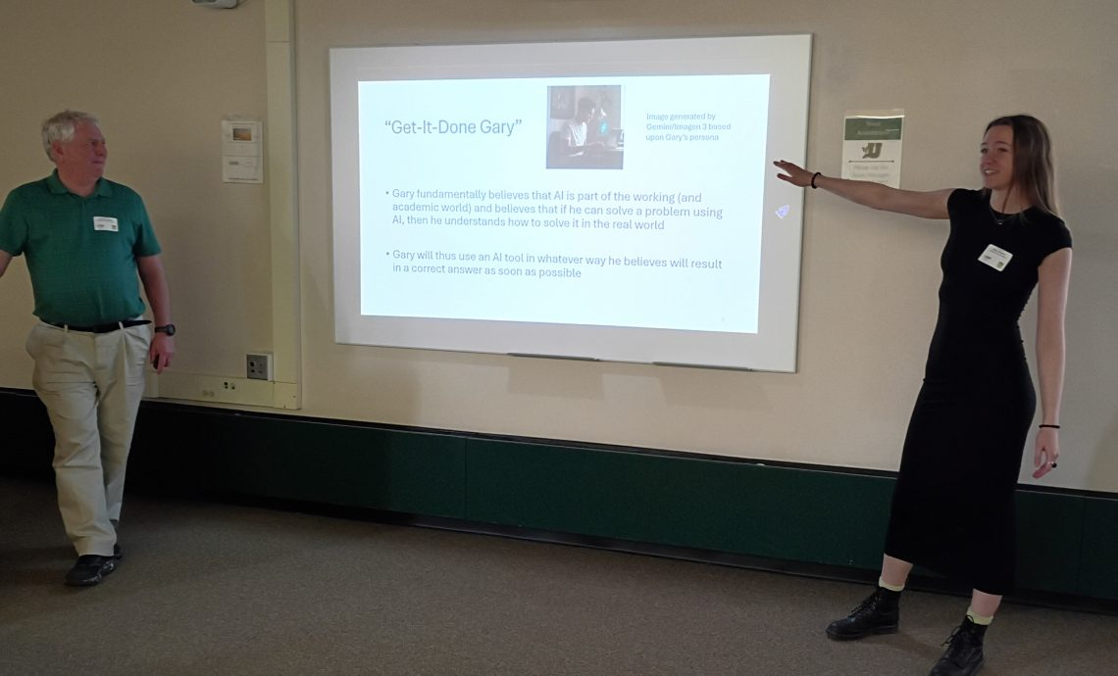

An AIIR Lab paper was recognized as the Best of the Labs paper in the SimpleText 2024 competition at CLEF (Conference and Labs of the Evaluation Forum). The team was led by Nick Largey (graduate student) and the paper was the outcome of the Text Mining and Analytics course.

Department of Environmental Science & Policy

Dr. Vanessa Levesque and two undergraduate students, Kaitlyn Macphee and Lily Newton, attended the American Association of Geographers annual conference in Detroit, MI in March, where they presented research that they both contributed to during 2024-2025. The title of their poster was “An Exploration of Resilience Adaptive Capacities in Rural Maine Municipalities.”

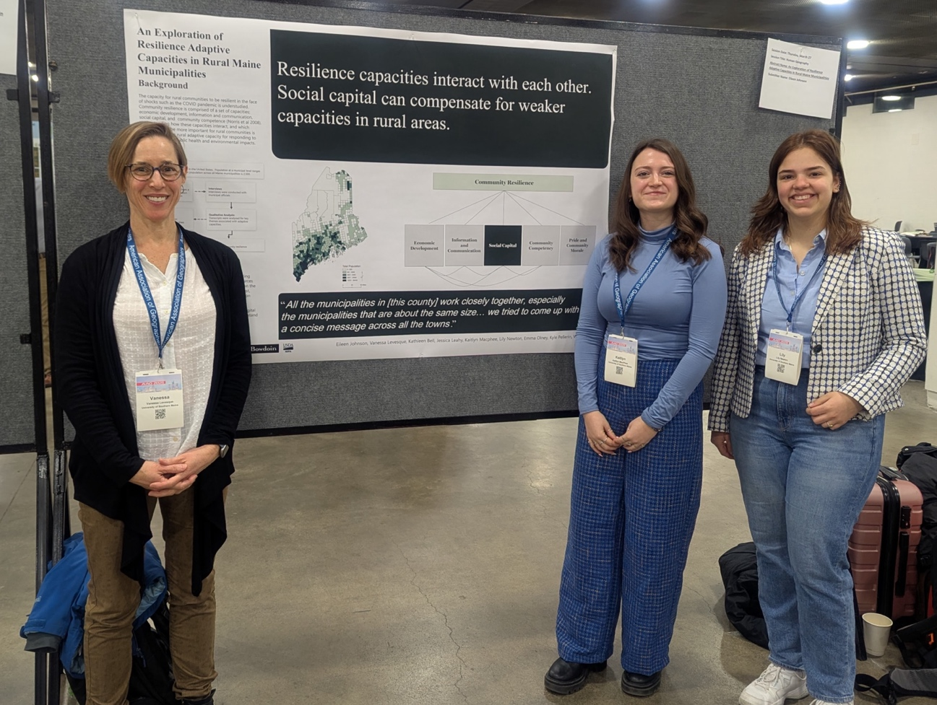

Department of Exercise, Health, & Sport Sciences

Dr. Kate Foley completed an EdD in Kinesiology from the University of North Carolina Greensboro this spring and was hooded on 8 May 2025. She plans to publish her work in the NAHKE International Journal of Kinesiology in Higher Education this summer.

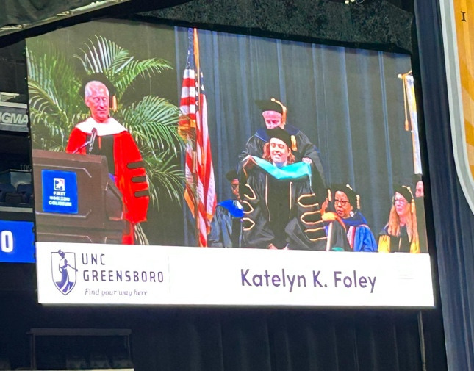

The Exercise Science program obtained the Education Recognition Program (ERP) status for Personal Training with the National Strength and Conditioning Association (NSCA) and is now recognized on the NSCA's website. This is the first step in a multi-year plan to build the program up with recognition in strength and conditioning and to be more involved with the NSCA. Dr. Kate Foley led the search and application of this certification, which is tied to her NSCA Personal Training certification and teaching at USM.

Department of Mathematics & Statistics

Dr. Muhammad El-Taha recently submitted a paper, “Classification of Discrete-Time Queues and Little’s Law,” that classifies discrete-time queues with scheduling rules into classes and uses this classification to address an unresolved issue that Little’s law does not apply for all these systems. The article also discusses the consequences of this classification on systems’ characteristics.

The Department of Mathematics and Statistics Early College Committee (Laurie Woodman, Silvia Valdes, and Abou El-Makarim Aboueissa) recently hosted an annual professional development Zoom meeting for MAT Concurrent Enrollment (CE) high school teachers. The meeting consisted of general Early College updates as well as content related breakout room discussions (Calculus or Statistics), concluding with breakout room reports. Teachers benefit from and appreciate this opportunity to interact with USM faculty and other CE instructors who teach the same course(s).

School of Nursing

Dr. Deb Gillespie and Associate Dean Bren Petersen recently published a book, Practical theories for nursing education: A multi-disciplinary perspective.

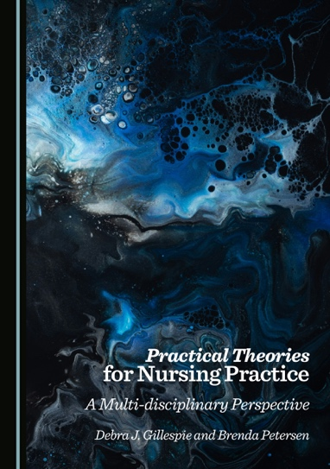
Nursing theories from the 1950-1970s may not fully address the complexities of today’s healthcare environment, as they are often content and context-specific. With the rise of Evidence-based Practice (EBP), staff nurses are expected to lead quality improvement and practice changes, aligning with Micro-systems Theory and the American Nurses' Credentialing Center’s Magnet Recognition Program. However, nurses typically learn nursing theory only in undergraduate and graduate programs, without exposure to change theories, quality improvement models, or EBP/translation theories from other fields like psychology and education. This book offers a concise overview of education, communication, and quality improvement theories that are practical and valuable for clinical practice. Each chapter provides a summary of these theories and supporting evidence for their use in practice, education, and research. Although written from a nursing perspective, the book is beneficial for any healthcare professional working in clinical, educational, or research settings.

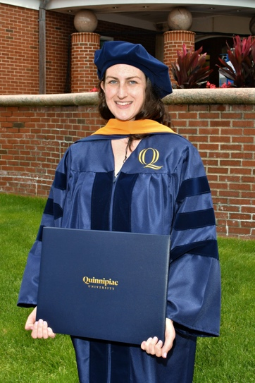
Dr. Ashley Condon completed a DNP from Quinnipiac University. Her capstone, “Improving Depression Screening Rates in a Primary Care Clinic,” was chosen from 30 presentations to be displayed at the College’s Interprofessional Scholarship Day.

Danielle Letourneau is entering the second year of her doctorate in Leadership Studies with a research focus on accessibility, ableism, and disability in higher education. This will be Danielle's third consecutive degree from USM (she also holds a BA and MFA).

Several staff were nominated for the 2nd Annual Staff Senate Commendation Awards.
For Achievement: Brandon Blount, Elizabeth Bahi, Sarah Powelson, Tim Conley, and Lindsay Larsen (Winner)

For Excellence: Danielle Letourneau and Stacey Whitney

For Advancing Equity: Brandon Blount

Brandon Blount won Student Employment Supervisor of the Year.

Department of Psychology

Dr. Betsy Parks-Stamm’s research network (including 5 members from UiT The Arctic University of Norway, University of Copenhagen, Denmark, University of Turku, Finland, and University of Southern Maine, USA) received a grant from the Research Council of Norway to put on a conference this August in Tromsø. It is called the Nordic Gender Conference on Men's Underrepresentation in Communal Occupations.

