Basic Accessibility Guidelines
This document includes information on making digital files accessible. The step-by-step instructions are for use in Word. Other programs offer similar options; please reach out to the OLLI Office if you need assistance.
Contents
General Guidelines 2
Font 2
Headings 3
Bullets & Numbered Lists 3
Bullets 3
Numbered Lists 4
Pictures & Images 4
Guidelines 4
Adding Alt Text 4
Links 6
Accessibility Checker (Word) 7
Accessible Word Template 7
Presentations (PowerPoint) 8
PDFs 8
Emails 8
Videos & Audio 9
Sharing a Video or Audio Clip 9
Creating a Video or Audio Clip 9
Online Course Transcriptions 9

General Guidelines
- Use the Styles, like Headings and Lists, that are provided in the software.
- All images need to have alt text added.
- Use only 1 space after end sentence punctuation or a colon.
- Do not write in all caps unless you are using an acronym. Writing something like “HELLO” will be read as “H E L L O” by a screen reader.
- If using an acronym, define it at the first use:
  - First use: Osher Lifelong Learning Institute (OLLI)
  - Second use: OLLI
- Tables can only be used for data and require specific header formatting (contact the OLLI Office). Do not merge cells.
- Create a strong color contrast between words and backgrounds. Best practice: black on white for text; dark blue on white for links.
  - Use a Contrast Checker tool. Contrast must meet AA guidelines.
- Do not use color alone to convey information:
  - Bad: Task 1, Task 2
  - Good: Task 1-complete, Task 2-incomplete
- Only use underline for links. Avoid italics.
- Do not indent using the space bar.
- Use 1.5 spacing between lines.

Font
- Fonts should be sans serif (clean looking without decorative strokes on the ends of the letters)
  - Some sans serif fonts include: Calibri, Arial, Helvetica, Verdana, and Lato.
  - Do not use the “thin” or “light” version of any font.
- Text size should be a minimum of 14 points whenever possible.

Headings
- Heading 1 is the main Heading inside the document. There should be only 1.
- Headings must be in order, like a Roman numeral outline. (Click on the headings in this document and see each style selected in order.) For example:
Heading 1
Content
Heading 2
Content
Heading 3
Content
Heading 3
Content
Heading 2
Content
Heading 3
Content

Bullets & Numbered Lists

Bullets
Use the Bullet list icon in the Paragraph section of the toolbar.
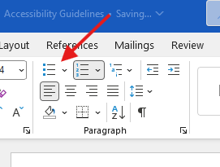

Numbered Lists
Use the Numbered list icon in the Paragraph section of the toolbar.
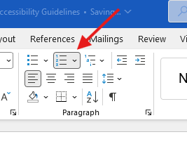

Pictures & Images

Guidelines
- All pictures and images must have Alt Text (alternative text) included so that electronic screen readers can tell a user what is in the photo.
- Alt Text should describe the picture with no more than 250 characters.
- If a graphic is purely decorative (a border design or other element) mark it as decorative in the Alt Text box.

Adding Alt Text
- Add an image to your document.
- With the image selected, right-click and a menu will pop up. Choose View Alt Text.
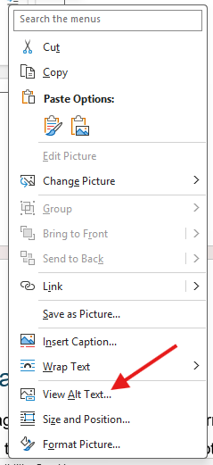
- A new window will open on the right-hand side of the screen where you can type in your Alt Text.
  - For example, if you were to use this photo in your document:

  - You could write this Alt Text:
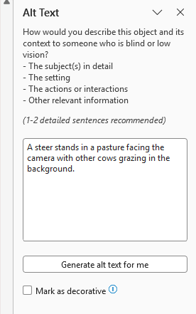
If you get stuck trying to access the Alt Text box, describe the image in the document itself and reach out to the OLLI Office.

Links
Use plain language when inserting a link into any document or email. A screen reader will read each letter and symbol. For example:
- Bad: https://usm.maine.edu/osher-lifelong-learning-institute/
- Good: Osher Lifelong Learning Institute
Highlight the description of the link and right click to select “Link” from the menu. Then paste the address in the link box.
Make sure you include where the link goes/what will happen:
- Bad: Click here
- Good: Join our Zoom class

Accessibility Checker (Word)
Word offers a built-in accessibility checker to help make sure your document is ready to share.
- When you’re done editing, go to the Review tab at the top of the document.
- Click on Check Accessibility
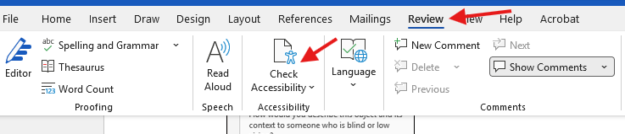
- The Accessibility Assistant will open a new window on the right-hand side. It will tell you if you need to address anything or if it “Looks good!”

Accessible Word Template
Styles are pre-programmed into our Accessible Word Template. Here is a recommended process:
- Open the Accessible Word Template and save a copy (File > Save a copy)
- Type your content into the document, then go back to format it.
  - For each section of information, highlight the text and select the correct format style.
  - Use the Styles section of the Word toolbar at the top of the document to select the correct style – the styles have been pre-programmed. (Use the dropdown arrow to see more options.)
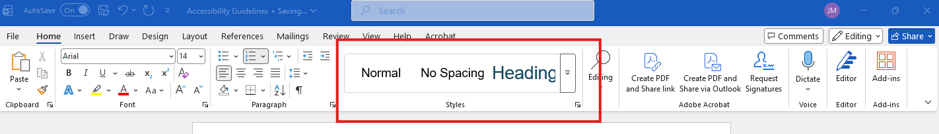

Presentations (PowerPoint)
- Make sure an appropriate reading order is assigned to each slide and each has a unique title.
- When presenting an image or graph, describe what is in the visual as you speak to the class.

PDFs
Avoid using PDFs whenever possible. A Word document is much more accessible.
If you must translate your document to a PDF, go to File > Save as Adobe PDF or File > Save As and select PDF. Do not print as a PDF – this option will not grab your Alt Text and headings.
***If you’re planning to share a PDF, you must send a copy to the OLLI Office for accessibility editing before sending to your class. Provide at least 1 week for edits.

Emails
Emails also fall under these accessibility rules. If you are just typing a short text message, follow the font guidelines above.
- If you are including a list: Use the bullet and numbered lists available in your email program.
- If you plan to attach a photo/image: Describe what is in the attachment.
  - For example: If you’re sending a map, instead of writing “See the attached map for directions” you could write, “We’re meeting at 381 High Street. The attached image has a map you can follow or you can enter that address into your GPS for directions.”

Videos & Audio

Sharing a Video or Audio Clip
- When showing a video or movie, display Closed Captions.
- Have a descriptive transcript available for audio clips.

Creating a Video or Audio Clip
- If you create and share or post a video, that video must have accurate Closed Captions. This includes sound effects and music.
- Any information presented only visually in a video must also be provided audibly including text information on slides, graphs or images, and visual demonstrations. The easiest solution is to have the speaker briefly describe any visual-only content. Alternatively, create a separate audio description track or descriptive transcript.
- Audio files must have an accompanying descriptive transcript.
- See the OLLI Office for detailed guidelines.

Online Course Transcriptions
All online classes must have a transcript available by request, even if you’re not recording the class. See our Current Faculty webpage to download a Zoom guide with directions on creating and sharing transcriptions.

