Basic Accessibility Guidelines in Word
Contents
Font & Size 1
Titles & Headings 2
Bullets & Numbered Lists 2
Bullets 2
Numbered Lists 3
Pictures & Images 3
Accessibility Checker 5
PDFs 6
Emails 6
Some Additional Advice 6

Font & Size
Fonts are pre-programmed into the template document. Fonts should be sans serif, at a minimum of 14 points. Here is a recommended process:
- Open the Accessible Word Template and save a copy (File > Save a copy)
- Type your content into the document, then go back to format it.
  - For each section of information, highlight the text and select the correct format style.
  - Use the Styles section of the Word toolbar at the top of the document to select the correct style – the styles have been pre-programmed. (Use the dropdown arrow to see more options.)
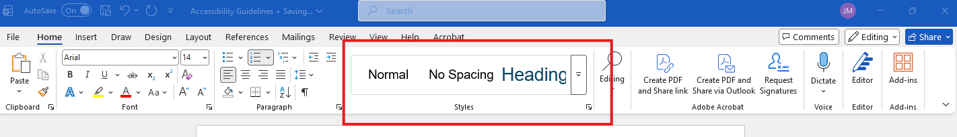

Titles & Headings
- Every document must have a Title
- Headings must be in order, like a Roman numeral outline. For example:
Heading 1
Content
Heading 2
Content
Heading 3
Content
Heading 3
Content
Heading 2
Content
Heading 3
Content

Bullets & Numbered Lists

Bullets
Use the Bullet list icon in the Paragraph section of the toolbar.
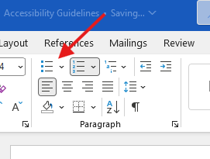

Numbered Lists
Use the Numbered list icon in the Paragraph section of the toolbar.
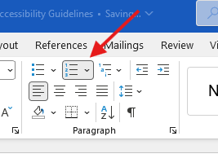

Pictures & Images
All pictures and images must have Alt Text (alternative text) included so that electronic screen readers can tell a user what is in the photo. Alt Text should describe the picture with no more than 250 characters.
- Add an image to your document.
- With the image selected, right-click and a menu will pop up. Choose View Alt Text.
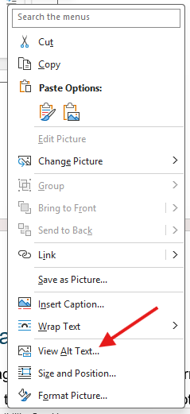
- A new window will open on the right-hand side of the screen where you can type in your Alt Text.
  - For example, if you were to use this photo in your document:

  - You could write this Alt Text:
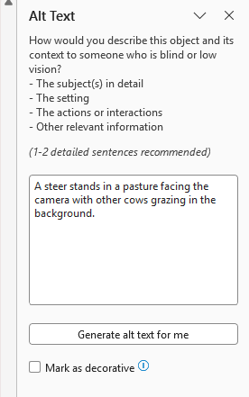

Accessibility Checker
Word offers a built-in accessibility checker to help make sure your document is ready to share.
- When you’re done editing, go to the Review tab at the top of the document.
- Click on Check Accessibility
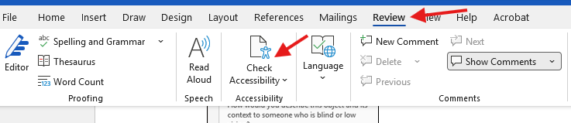
- The Accessibility Assistant will open in a window on the right-hand side. It will tell you if you need to address anything or if it “Looks good!”

PDFs
If you MUST translate your document to a PDF, go to File > Save as Adobe PDF or File > Save As and select PDF. Do not print as a PDF – this option will not grab your Alt Text and headings.
***If you’re planning to share a PDF, please send a copy to the OLLI Office for accessibility editing before sending to your class. Provide at least 1 week for edits.

Emails
Emails also fall under these accessibility rules. If you are just typing a short text message, there is no additional step to take.
- If you are including a list: Please use the bullet and numbered lists available in your email program.
- If you plan to attach a photo/image: Describe what is in the attachment.
  - For example: If you’re sending a map, instead of writing “See the attached map for directions” you could write, “We’re meeting at 381 High Street. The attached image has a map you can follow or you can enter that address into your GPS for directions.”

Some Additional Advice
- If you get stuck trying to access the Alt Text box, describe the image in the document itself.
- Keep your font at 14 points or larger whenever possible.
- If you’re sharing a link, it’s best to write where the link goes instead of the URL itself.
  - For example: Instead of writing “Here’s the Zoom link: https://maine.zoom.us/j/88142951764?pwd=VhO384Vfv0Xlxtu6q128d7kJ12LY2Y.1” which makes an electronic reader say every item in the address, you can write “Here’s the Zoom link for our Civil Liberties class.”
  - Highlight the description of the link, and right click to select “Link” from the menu. Then paste the address in the link box.
- If you’re using color, make sure there is enough contrast to be easily read. Best practice: black on white for text; dark blue on white for any links.

