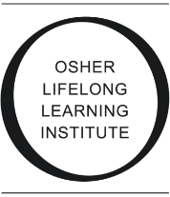
OLLI @ USM Feedback Form

Survey questions for students in
{course title, session, year}

- What did you like or dislike about the class? Do you have any suggestions that would have enhanced your experience?

- What did you think of the overall class theme of {topic} and the books that we read together?

- Do you have a suggestion of a book or theme for a future class, keeping in mind that it should be {genre}?

- Facilitating the discussion of one of the books is a way to dive deeply into a book and form bonds with a classmate. Would you be interested in facilitating a book discussion in a future class?

- Do you have any other comments that were not captured in this survey?

Thank you for participating in the class!

