
OLLI @ USM Feedback Form
This survey was created in Google Forms.
It is recommended for online class feedback.
Here are some tips on making Google Forms accessible.
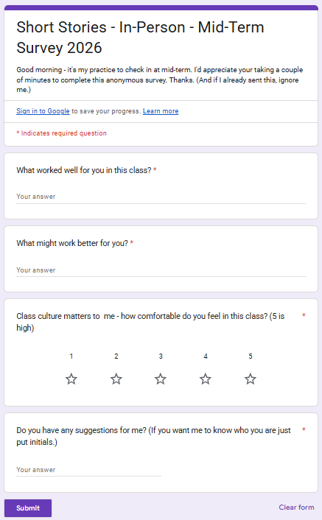

Short Stories – In-Person – Mid-Term Survey 2026
Good morning – it’s my practice to check in at mid-term. I’d appreciate your taking a couple minutes to complete this anonymous survey. Thanks. (And if I already sent this, ignore me.)

- What worked well for you in this class?
- What might work better for you?
- Class culture matters to me – how comfortable do you feel in this class? (5 is high)
- Do you have any suggestions for me? (If you want me to know who you are just put initials.)

