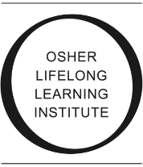
OLLI @ USM Feedback Form

{Course Title}

Participant Survey

- Class Presentation
  - Did the course meet your expectations of what you wanted to learn?
  - Were there topics you would have liked to explore that were not covered?
  - Were the videos helpful in providing relevant information?
  - Do you have suggestions on what would make the course or presentations better?
- Book
  - If you read the book, how would you rate the book as far as general writing and then {topic} information?
  - Would you recommend the book?

- Other Comments or Suggestions

