Guide to Creating an OLLI Account
Welcome to OLLI! If you are new to OLLI or are a returning member who has not registered since 2024, you will need to create a new account.

Create an OLLI Account
- Open the OLLI Registration page.
- Click the blue button to Sign In or Create Account.
- On the Sign In page, scroll down to the Create New Account section on the right-hand side.
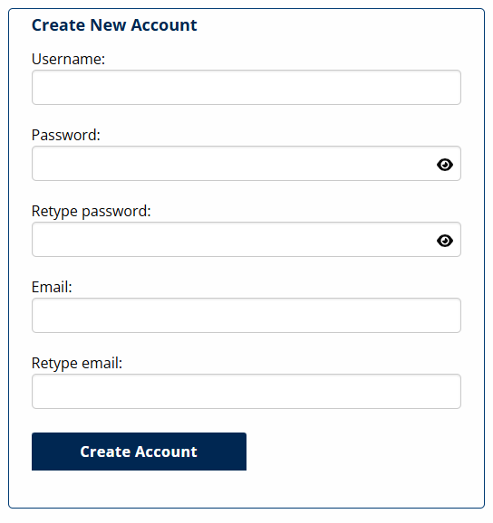
- Create a Username. We recommend your email address.
- Create a password. This must be a minimum of eight characters. It is case sensitive. You may use any combination of upper and lower case letters, numbers, and special characters (!@#$%^&*-+=|?/\).
  - You can click on the eye icons to see your password as you type. 
- Add your email address.
- Click Create Account
- A form will pop up asking for contact information. Please enter:
  - Name
  - Address
  - Phone
  - Date of Birth
  - Emergency Contact Information
- Check over the information, then click Submit at the bottom of the form.
- You will be returned to the Registration Home page. You will see your name in the banner image:

Your name

Don’t see your name?
If you don’t see your name, you are not signed in. Please try to sign in by clicking the Sign In. If you created a new account but left the site before paying your membership, you will want to sign in using the Existing Account option.

Questions?
Call the OLLI Office at (207) 780-4406.

