Guide to OLLI Registration
If you are new to OLLI or are a returning member who has not registered since 2024, you will need to create a new account. Please see the Guide to Creating an OLLI Account on our Registration Information page.
To register for courses or workshops, you will need to:
- Sign in to your OLLI Account
- Purchase an OLLI membership
- Register for the course/workshop
Sign In to Your OLLI Account
- Go to the OLLI Registration page.
- Click the blue button to Sign In or Create Account.
- On the Sign In page, scroll down to the Sign in to Existing Account section on the left-hand side.
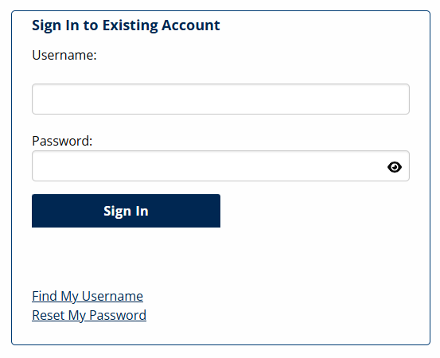
- Enter your Username and Password. You can click on the eye in the Password box to see your password as you type.
  - If you forgot your Username, use the Find My Username link.
  - If you forgot your Password, use the Reset My Password link.
- Click Sign In. You will return to the Registration Homepage. Check that your name appears in the top left of the page next to “Welcome.” If you see your name, you have successfully signed in. 
Your name
  - If you don’t see your name, you are not signed in. Try signing in again and be sure to click Submit.

Purchase Your Annual Membership
- You must be signed in to your OLLI account to pay your annual membership fee.
- Go to the Registration Home page.
- Scroll to the bottom of the page and select the Membership option in the grid.

- On the Membership page, scroll down to see the Membership Fee selection.
- Click the Add to Cart button.

- You will see Your Cart open on the right-hand side. Click Check Out and pay with your credit card – or continue shopping for courses/workshops and pay at once.
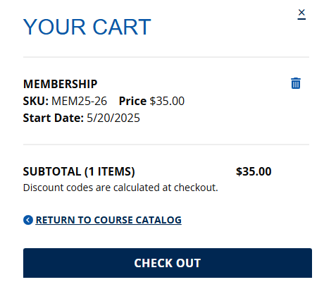
Thank you!!!

Register for a Course or Workshop
- You can register for OLLI classes and workshops with a paid current membership or if you add a current membership to your cart. Start on the Registration Home page.
  - Confirm your name still appears in the upper left.
- Find courses and workshop:
  - Scroll to the bottom of the page and select the category you would like to browse.
  - If searching for courses, you will see search options by:
    - Topic Areas
    - Schedule (days of the week and time block)
    - Osher Online
    - Delivery Style (in-person or Zoom)
  - Or you can search a specific course name by clicking on the Search button in the banner at the top of the page.
- Add the course(s)/workshop(s) you would like to your cart and check out.
  - If you don’t see an Add to Cart button:
    - Registration may not yet be open.
    - You may not be signed in.
    - You may need to renew or add your annual membership to your shopping cart.
- Be sure to note if the course you are signing up for is in-person, remote, hybrid (both in-person and remote concurrently), or blended (some sessions in-person and some sessions remote).
