

Changing your USM/UMS Password
UMaine passwords must be changed every 180 days.
- Log into MyCampus using your UMS credentials.
- Click on the padlock icon in the launch pad.
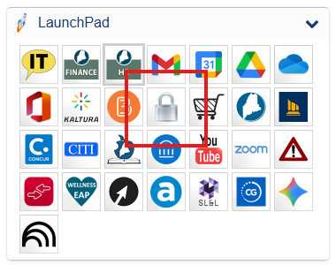
  - You may be asked to re-enter your current User ID and Password.
- You will then see a UMS Account Password Change form where you enter your old password, then enter a new one.

