Apple Pages Accessibility Guide

Simple Step-by-Step Instructions
Use this guide to make your documents clear, readable, and accessible for everyone. For use in conjunction with the Accessibility Guide.
Contents
Apple Pages Accessibility Guide 1
Simple Step-by-Step Instructions 1
Headings 2
Lists 3
Images 4
Text 4
Links 5
Tables 5
Color 5
Export to Word 5
Final Check 5
Teaching Tip 5

Headings
- Highlight your section title
- Click the “Paragraph Styles” menu (top toolbar)
- Choose Heading or Subheading
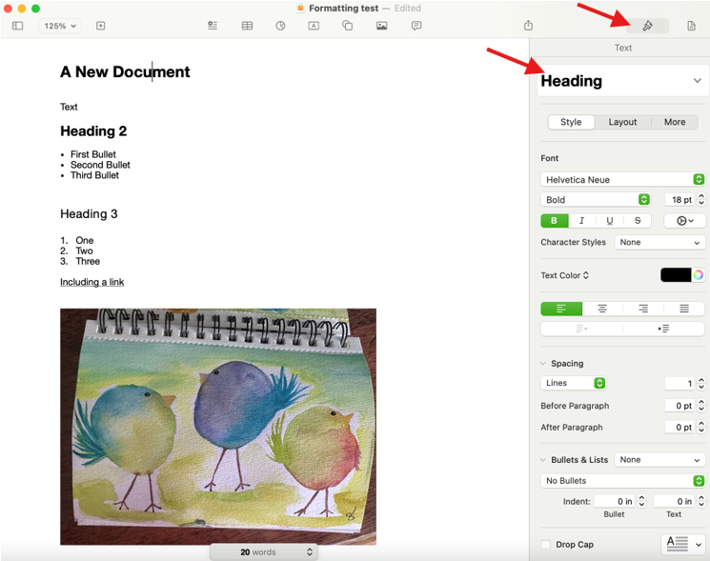
Tip: Do not just make text bigger or bold. If you don’t like the font that is the default in your heading, you can change it after you tag the text.

Lists
- Highlight your list items
- Click the bullet or number list button
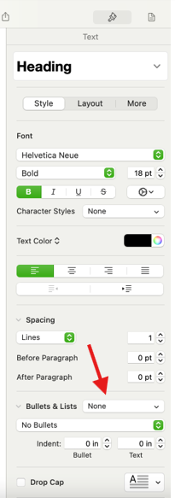
Tip: Do not type dashes manually

Images
- Click the image
- Open the Format panel (right side)
- Find “Description”
- Type a short description (<125 characters)
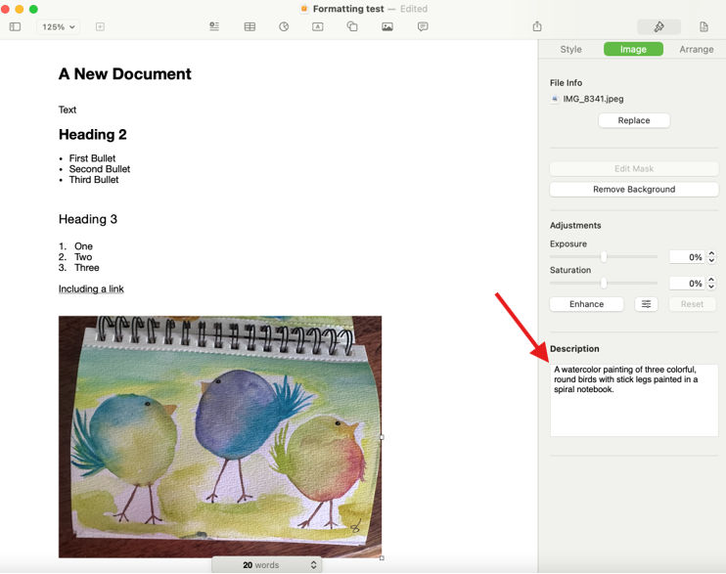
  - To see a word count, write your description in the body of the document. Highlight it and click View > Show Word Count. You can then cut the description from the body of the document and paste it into the Description box.

Text
- Use font size 14–16 or larger
- Choose simple fonts (Arial, Helvetica)
- Use dark text on a light background
- Avoid all caps

Links
- Highlight the text
- Press Command + K (or use the link button)
- Add the web address
✔Good: “View the syllabus” ✖ Avoid: “Click here”

Tables
- Click the table
- Open Format panel → Table
- Turn on Header Row
- Do not merge cells

Color
Do not use color alone to convey meaning/information. Add labels like “Important” or “Required.”

Export to Word
- Click File → Export To → Word document

Final Check
Ask yourself:
- Is this easy to read?
- Are sections clearly labeled?
- Are images described?

Teaching Tip
Give both written and spoken instructions. Go slowly and repeat key points.

